Common Mode Choke Parts List
- 1 4x4x2 PVC Electrical Box
- RG400 Coax (You can get 10’ on Amazon for $18.99)
- 8 #6-32 x ½” bolts
- 8 #6-32 nuts
- 4 #6 star lock washers
- 2 Chassis mount SO-239
- 1 FT240-31 Toroid (I will order for you)

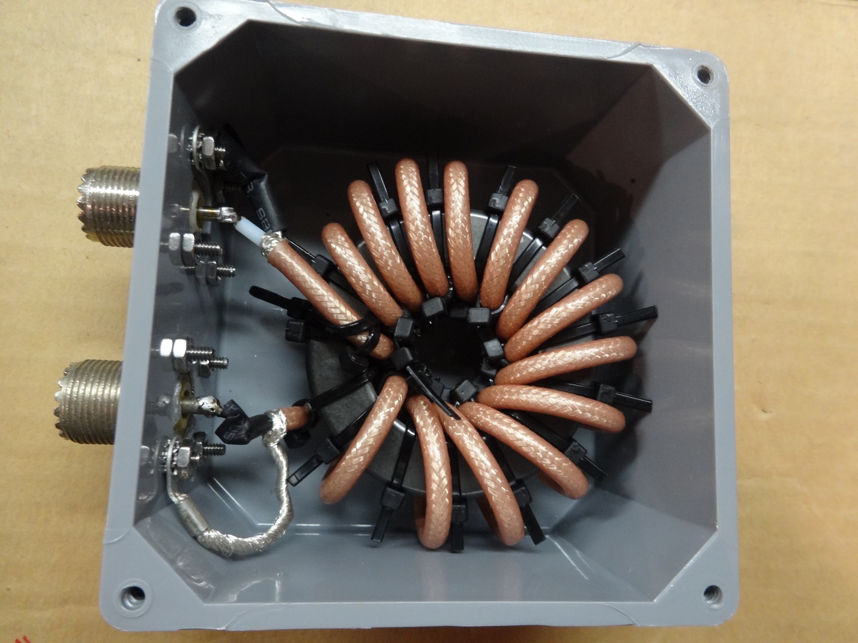
Picture compliments of Fred W9KEY

